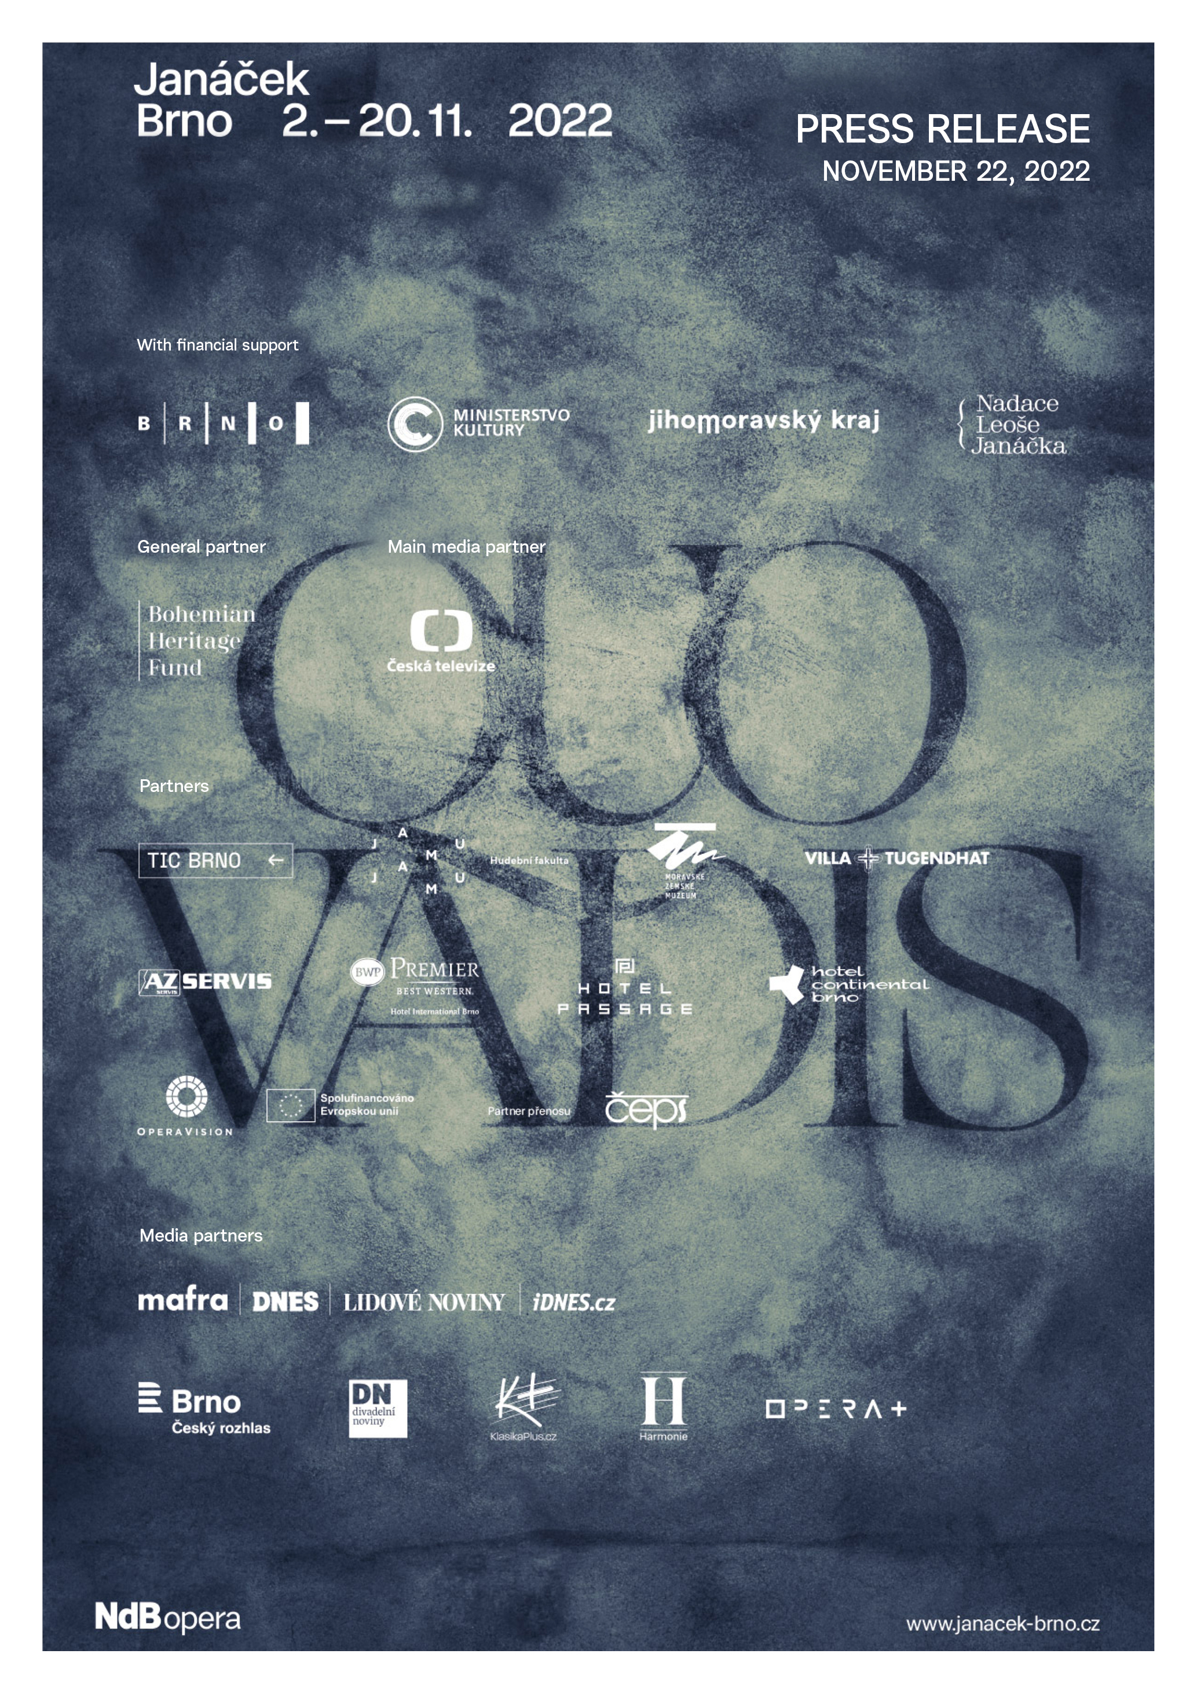

Janáček Brno festival has had another successful year and record sales
Press release of 22 November 2022
Once again something quite extraordinary has been achieved in Brno – the internationally highly acclaimed Janáček Brno festival brought a world-class programme from 2 to 20 November, to which both the Czech and foreign public reacted positively with large audience numbers. The city where Leoš Janáček lived and worked, and which is essentially linked to the festival is making full use of its assets and with an ever-increasing standard. The festival has proven that even the coronavirus restrictions of last year did not diminish the interest of the audience, which has been demonstrated by the highest sales in the history of the festival. But Janáček Brno 2022 is not over yet – the last “echo” in the form of the performance From the House of the Dead / Glagolitic Mass on 26 November is still scheduled, so the numbers will grow even higher.
With the presentations of top conductors Jakub Hrůša, Tomáš Hanus, Tomáš Netopil or Marko Ivanović, perfectly coordinated foreign ensembles such as the Welsh National Opera, Orchestre de la Suisse Romande, the Swiss Grand Théâtre de Genève, Orchestra of the Prague National Theatre and Janáček Opera of the National Theatre Brno, and also thanks to renowned soloists, performers and directors such as Corinne Winters, Nicky Spence, Adam Plachetka, John Fiore, Viktoria Mullova, Olivia Fuchs, Calixto Bieito and Tatjana Gürbaca, the festival has lived up to its reputation. By presenting the key works of Leoš Janáček, often in multiple interpretations, the festival created not only an experiential but also a comparative platform for discussion and reflection of the festival by the professional public.
In numbers, Janáček Brno 2022 surpassed many limits: an example is the sales of festival tickets, which totalled a record of CZK 4 269 249. The festival was attended by 10 744 paying spectators, so the average attendance was 73,3 %. The growing trend in key indicators is a positive spark and driving force for the main organiser of the festival, the National Theatre Brno. “We are delighted with the excellent results, but they do not even come close to capturing the intensity of the energy that flowed between the stage and the auditorium at all the performances and concerts. The warmth and enthusiasm with which the audience enjoyed the festival production was truly priceless. Personally, I am extremely proud of what the entire organizing team has accomplished. The situation, which was extremely complex and uncertain after several waves of the pandemic, has been further complicated by the economic crisis. Negotiating and putting together such a top-notch programme would not have been possible without the great and passionate professionals at the National Theatre Brno,” says Martin Glaser, director of the National Theatre Brno.
During the 19 days, a total of 36 productions were performed, some of which were world premieres or constituted a programme specially created for the festival. The younger generation, led by the Janáček Academy of Music and Performing Arts in Brno and the Brno Conservatory, was also given space.
The home premiere of From the House of the Dead / Glagolitic Mass by the Janáček Opera of the National Theatre Brno received very good reviews and crowned its three, well attended, performances with an online stream via OperaVision, which was broadcast worldwide and will be viewable on the operavision.eu website until 6 May 2023. “I consider it an extraordinary achievement to bring together the top Czech conductors in one festival and thus make their world-first interpretation of Janáček operas available to the audience. The eighth year of the festival has undoubtedly been one of the best in the history of this Brno cultural festival with a great international impact. With the premiere of From the House of the Dead in conjunction with the Glagolitic Mass, the Janáček Opera ensemble defended its international reputation not only with the audience, but also with foreign critics, including the live broadcast of the performance as part of the international Opera Vision project. The unique projects of the youngest artistic generation of the Brno Conservatory and the Janáček Academy of Music and Performing Arts contributed to the success of the festival,” says Jiří Heřman, director of the Janáček Opera of the National Theatre Brno.
The accompanying programme in cooperation with TIC Brno was very popular, and the Janáček routes with locations where Janáček spent his time, composed or taught were also successful. Among other things, Janáček appeared in many places in the centre of Brno, where it was possible to listen to music samples after scanning the QR code. The field of gastronomy was also interesting – nine restaurants (like Janáček’s nine operas) offered “Janáček menus”, tastings of Janáček’s favourite delicacies according to the recipes of his housekeeper Marie Stejskalová.
Although the sales behaviour changed noticeably and left the organisers waiting longer for the packed halls as visitors made more last-minute purchases, it was still a pleasant surprise to see the strength of the foreign audience at the festival. “After two years of intensive preparation, it is wonderful to see the return of international audiences from all over the world to the festival. We are grateful for the indescribable atmosphere that the audience can only experience in a city that is so strongly connected to Janáček,” adds Pavel Lojda, secretary of the Janáček Brno festival. The festival have recorded purchases from Slovakia, Austria, USA, Germany, Great Britain, France, Switzerland, Hungary, Netherlands, Poland, Japan, Ireland, Canada, Spain, Italy, Brazil, Belgium, Sweden, China, Croatia or Indonesia. In the period of 2022, the traffic at the janacek-brno.cz website was 160 000 users. Press coverage this year covered not only the Czech and Slovak Republics, but also Great Britain, Austria, Hungary, Spain, Canada and the United States.
The festival was organized with the financial support of the Statutory City of Brno, the Ministry of Culture of the Czech Republic, the Region of South Moravia and the Leoš Janáček Foundation. The Bohemian Heritage Fund was a generous general partner of the festival. The media partner is Czech Television and the OperaVision partner is ČEPS. Festival partners: TIC Brno, Janáček Academy of Music and Performing Arts in Brno, Moravian Museum, Vila Tugendhat, AZ Servis, Hotel International Brno, Hotel Passage and Hotel Continental. The festival was held under the patronage of the Prime Minister of the Czech Republic Petr Fiala, the Minister of Culture Martin Baxa, the Governor of the South Moravian Region Jan Grolich, the Mayor of the Statutory City of Brno Markéta Vaňková, the Ambassador of the United Kingdom of Great Britain and Northern Ireland in the Czech Republic Nick Archer and the Ambassador of the Swiss Confederation in the Czech Republic Philippe Guex.
Selected festival photos are available for download on the festival Flickr (thank you for giving credits): https://bit.ly/FestivalJanacekBrno
The Janáček Brno 2024 festival will take place between 1 and 24 November 2024. Pre-sale of tickets for the festival will be officially launched on 4 November 2023. The festival is also planning a series of preview events for next autumn. All information about the festival, including archives of past years, can be found on the website www.janacek-brno.cz

JANÁČEK BRNO 2022
8th International Opera and Music Festival
QUO VADIS

Contact:
Alena Navrátilová Ochrymčuková
PR and marketing of Janáček Opera of the National Theatre Brno
e-mail: ochrymcukova@ndbrno.cz
phone: +420 702 267 991

